Problem No: 1

Problem Statement: Generate a sinusoidal signal using MATLAB.

Codes:
clc; clear; close all;
A = 1; f = 5; t = 0:0.001:1;
y = A * sin(2pif*t);
figure;
plot(t,y);
grid on;
title("Sine wave");
xlabel("Time (s)");
ylabel("Amplitude");

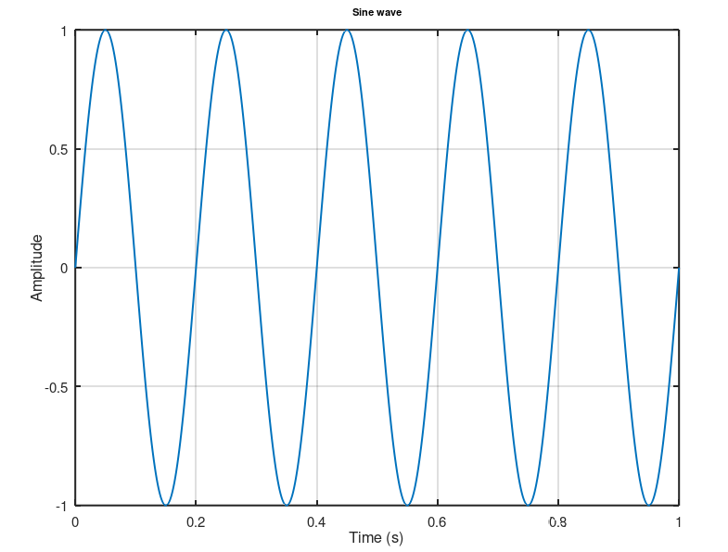
Output:

